Easter Message
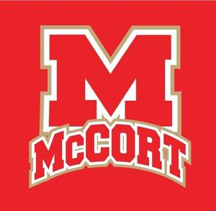
An Easter message from Jo-Ann Semko, Diocesan Director of Education.
#witnessthedifference #mccortcrushers #faithfirst

Dear Bishop McCort Catholic High School Families,
Easter is the greatest feast in the Christian calendar. On Easter Sunday, Christians celebrate the resurrection of Jesus Christ from the dead. For Catholics, Easter Sunday comes at the end of 40 days of prayer, fasting, and alms giving known as Lent. Through spiritual struggle and self-denial, we have prepared ourselves to die spiritually with Christ on Good Friday, the day of His crucifixion, so that we can rise again with him in new life on Easter. Easter is truly a day of celebration because it represents the fulfillment of our faith as Christians.
This lent has been quite different for all of us as we have been sheltering in place because of the COVID-19 pandemic. I have watched as our administrators, teachers, students, and families have struggled with this "new normal" and have seen families come together like never before. I have seen moms and dads grow in appreciation for the work of our schools and a newfound appreciation for all the things their children are learning each day. I have seen grandparents lovingly caring for their grandchildren because their sons and daughters are first responders and need to work each day. I have had the privilege of praying the Divine Mercy Chaplet every day at 3:00 and offering my prayer for the school communities of the Diocese of Altoona-Johnstown. We may be tired and maybe a bit fearful right now but we must always remember that our Lord and Savior, Jesus Christ died on the cross for each of us so that we may one day rise with Him to everlasting life. From darkness comes great light and I look forward to celebrating that great light with each of you.

Have a blessed Easter,
Jo-Ann Semko
Diocesan Director of Education

