Mahana Kodzo Oral History Photographs

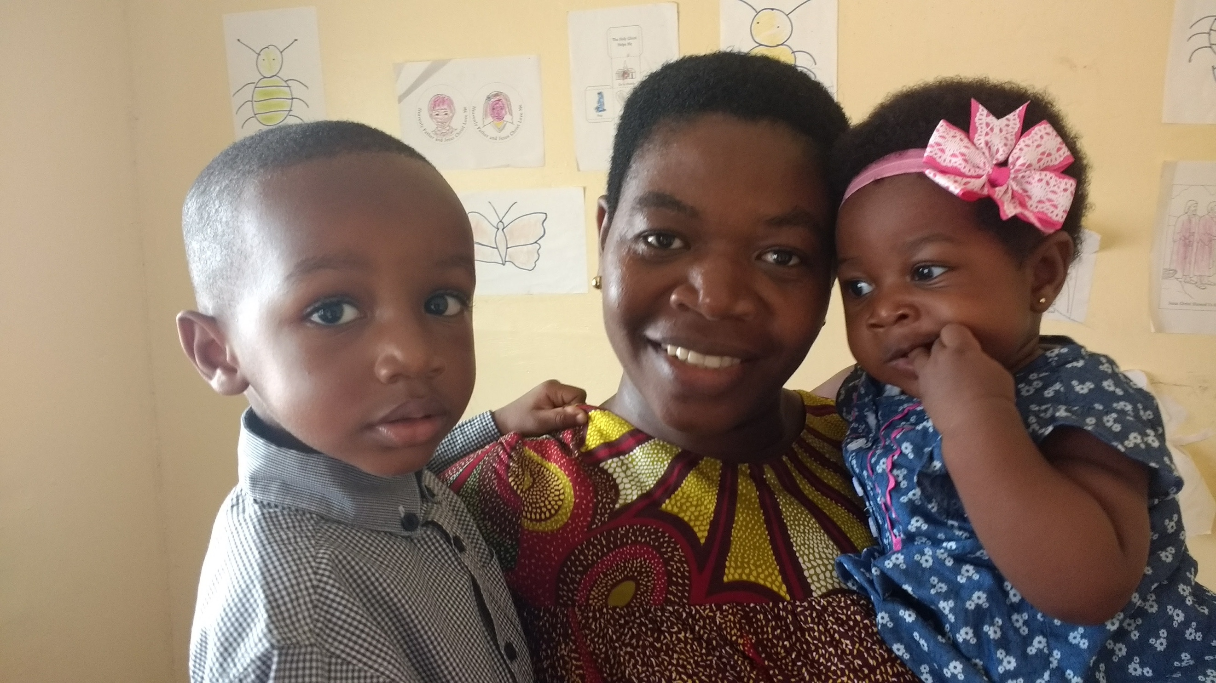
T J, Mahana and Aria

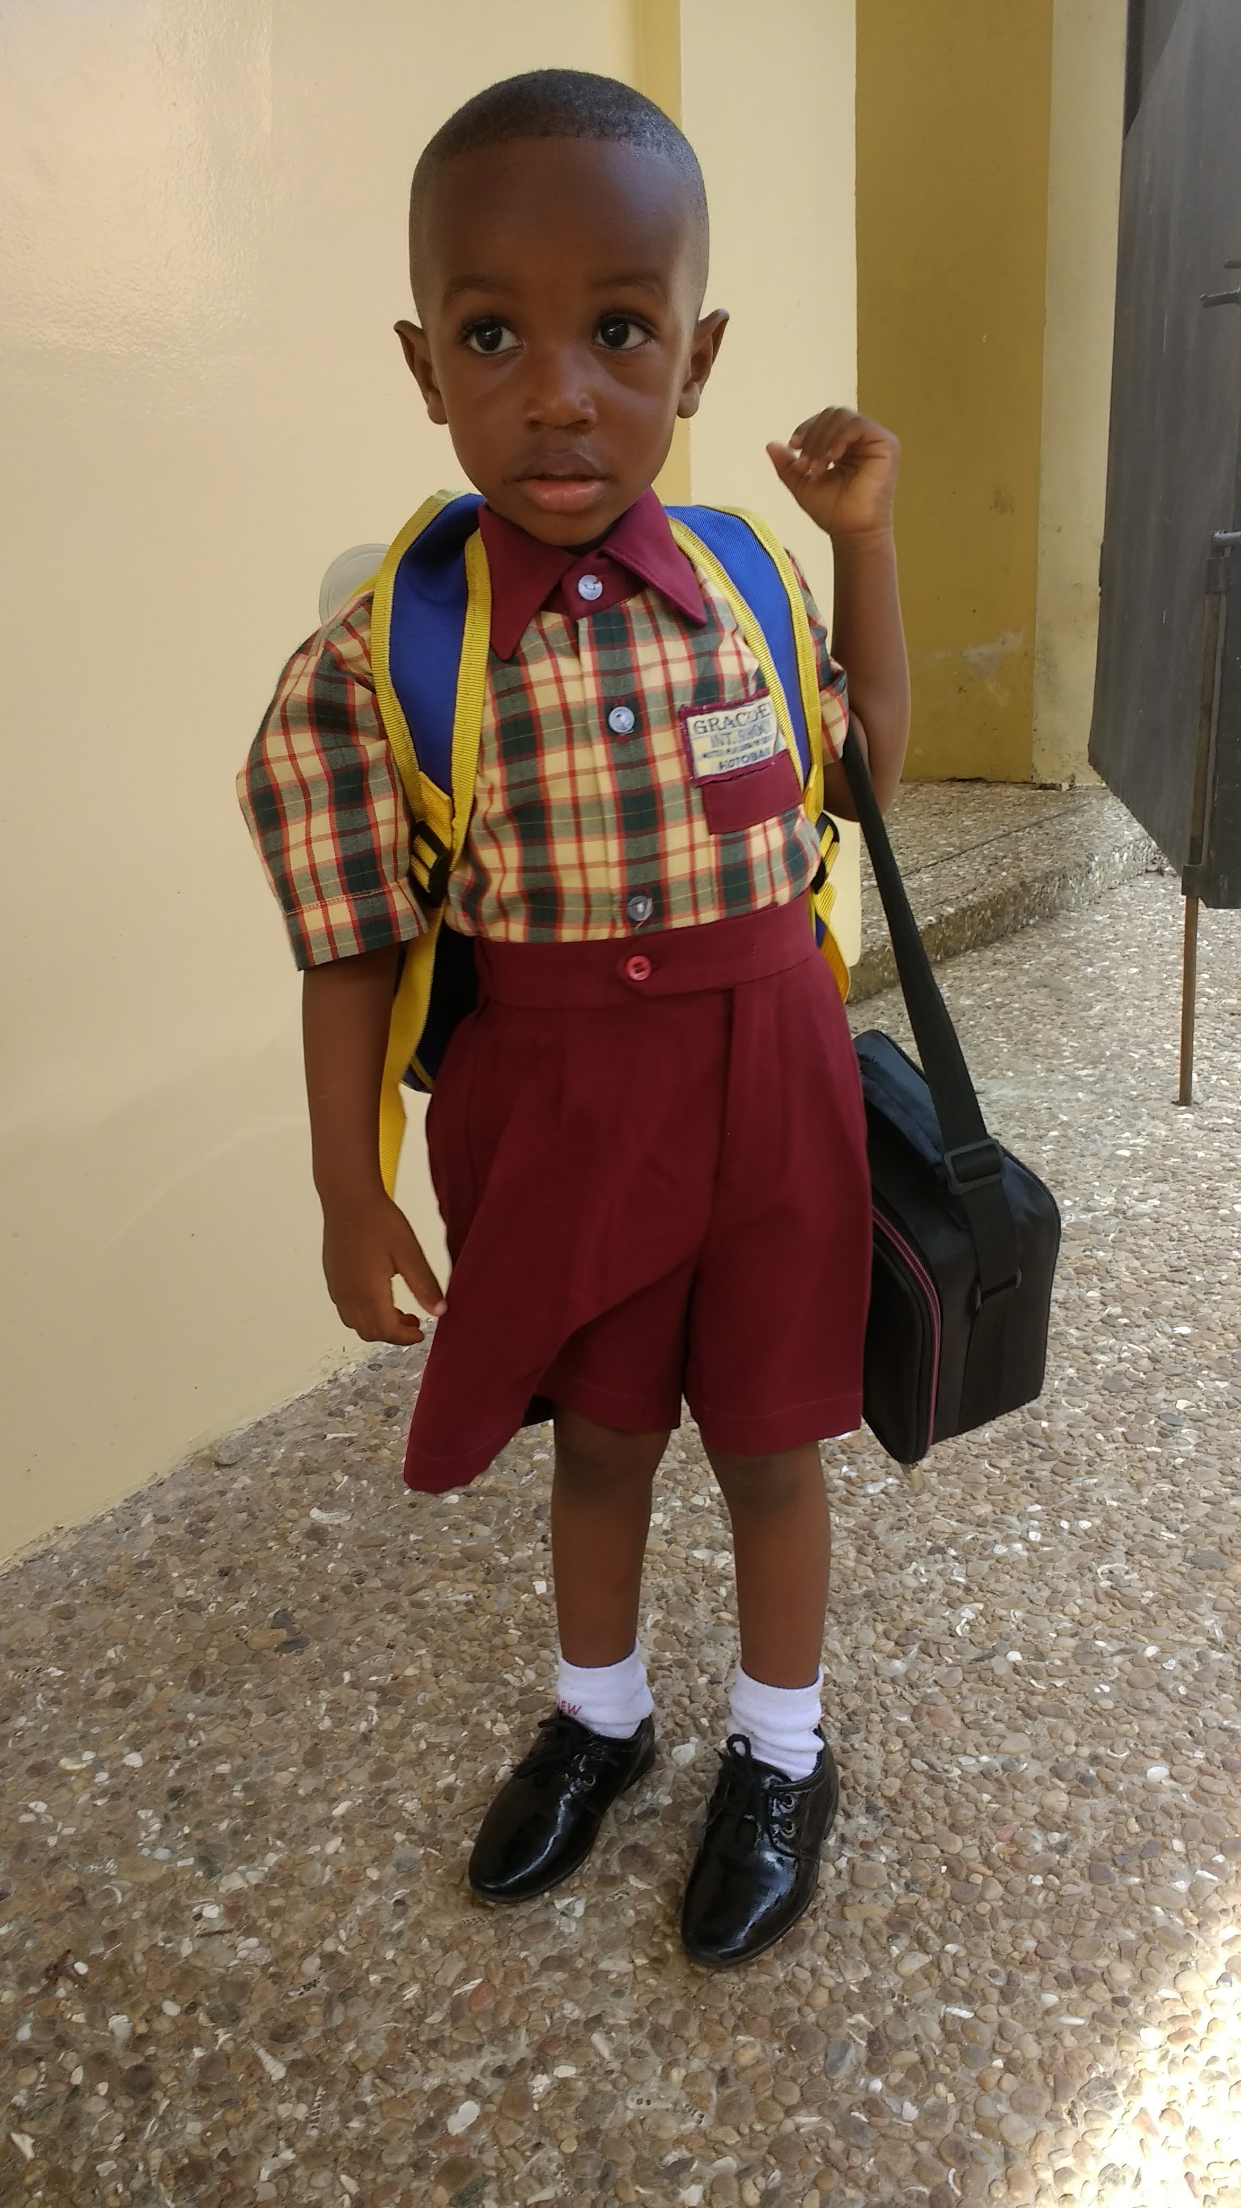
TJ
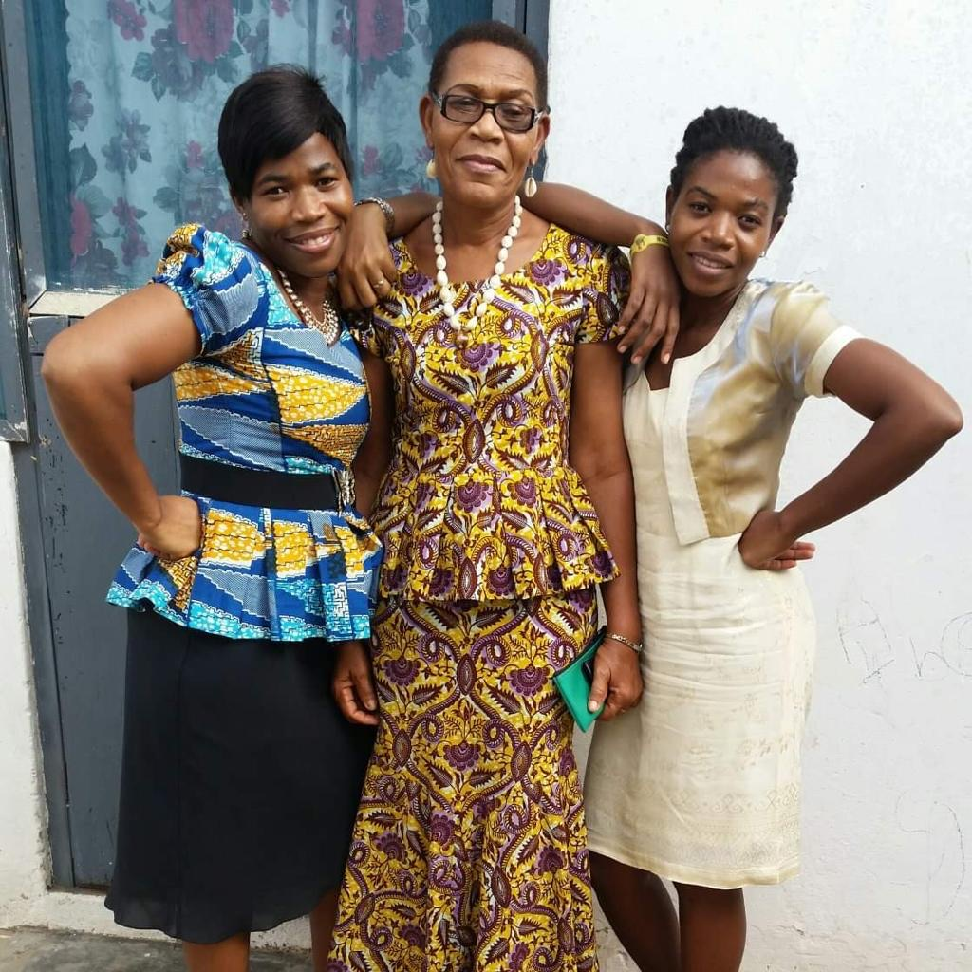
Mahana, her mom, Rose Ocantey Kodzo and sister, Lalit.

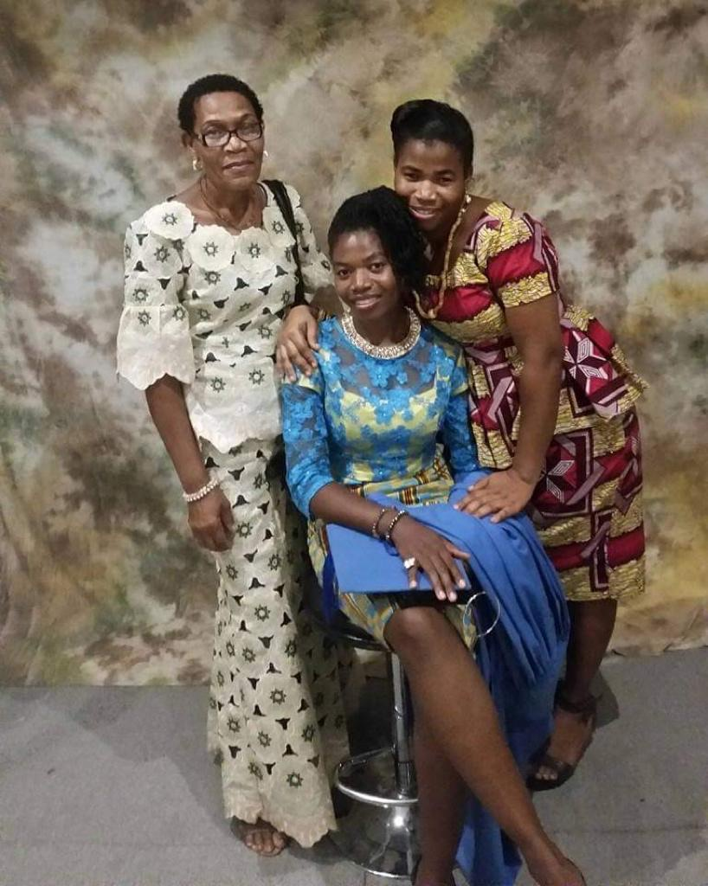
Three beauties-Mahana’s mom, Lalit and Mahana.

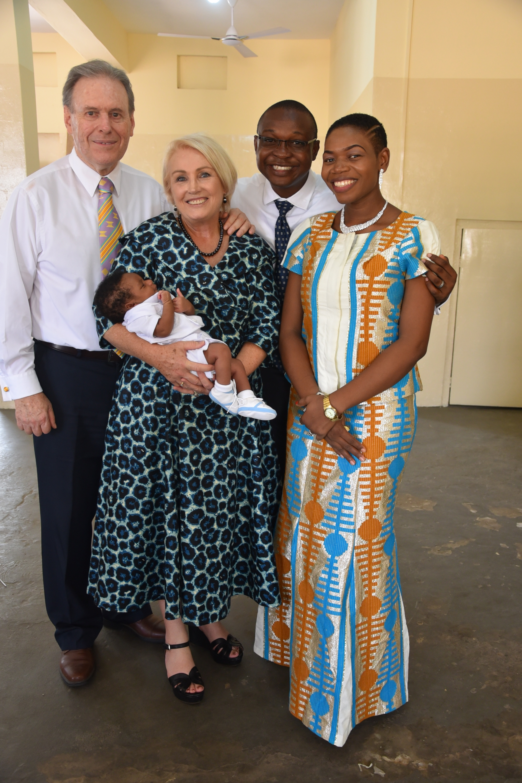

Elder and Terence Vinson, Baby T.J. and Mahana and her husband Cuthbertus Hazel- Acolatse at the T J’s blessing.

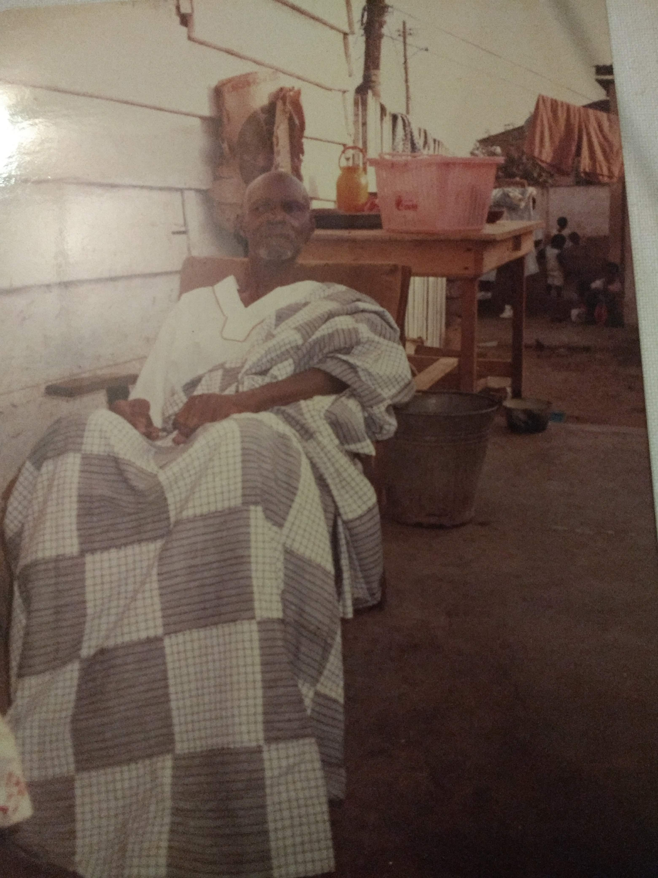
Mahana’s mother’s father, Erasmus Anong Okantey.

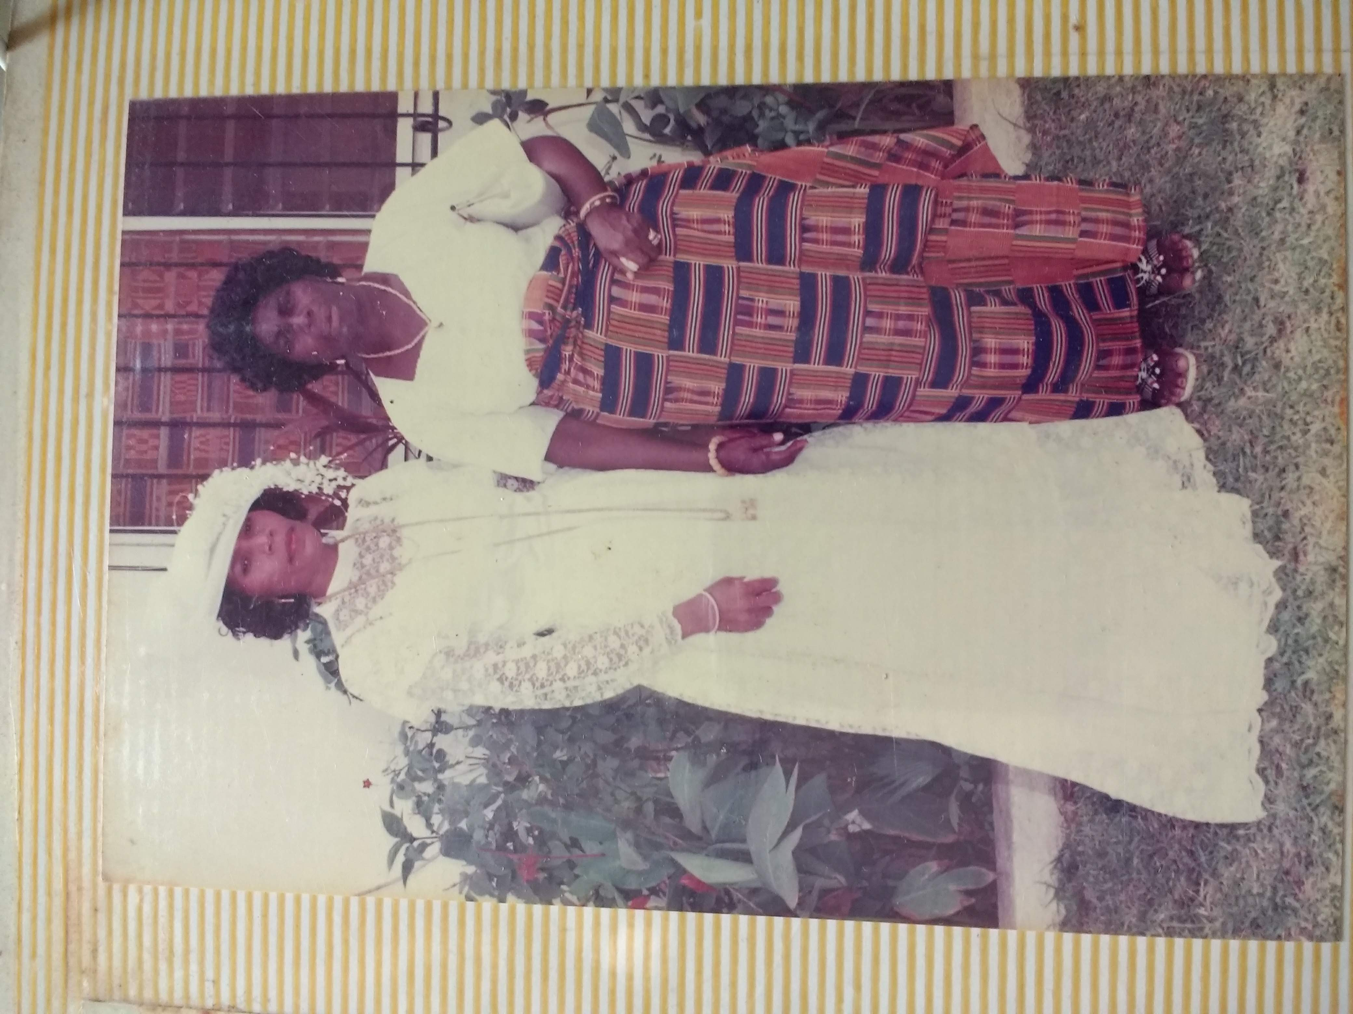
Mahana’s mum and Mahana’s father’s mum.

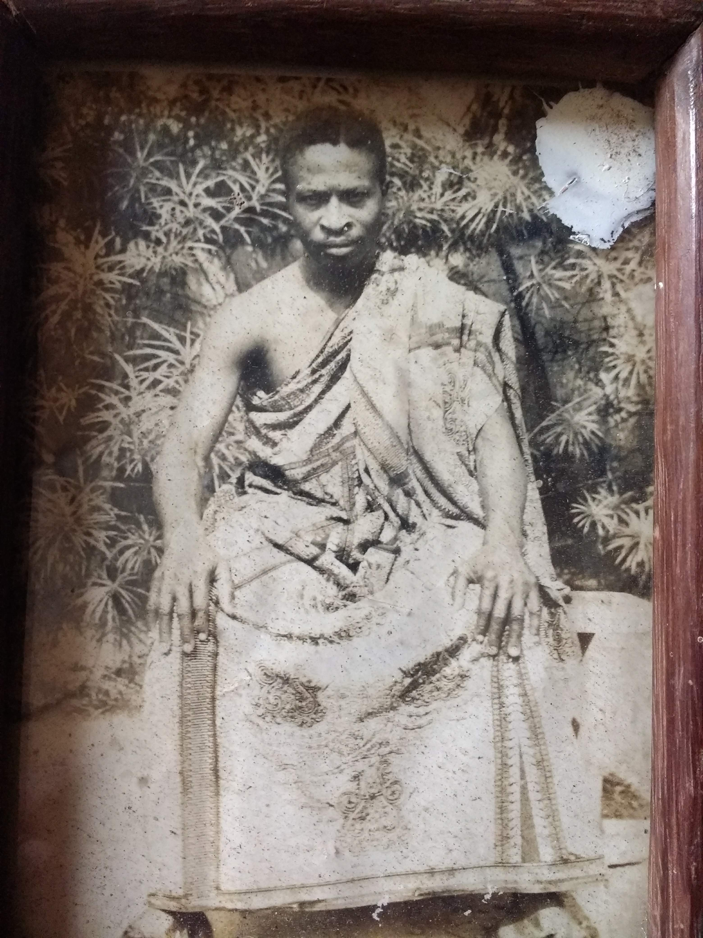
Mahana’s father’s father, Kodzo Alou.

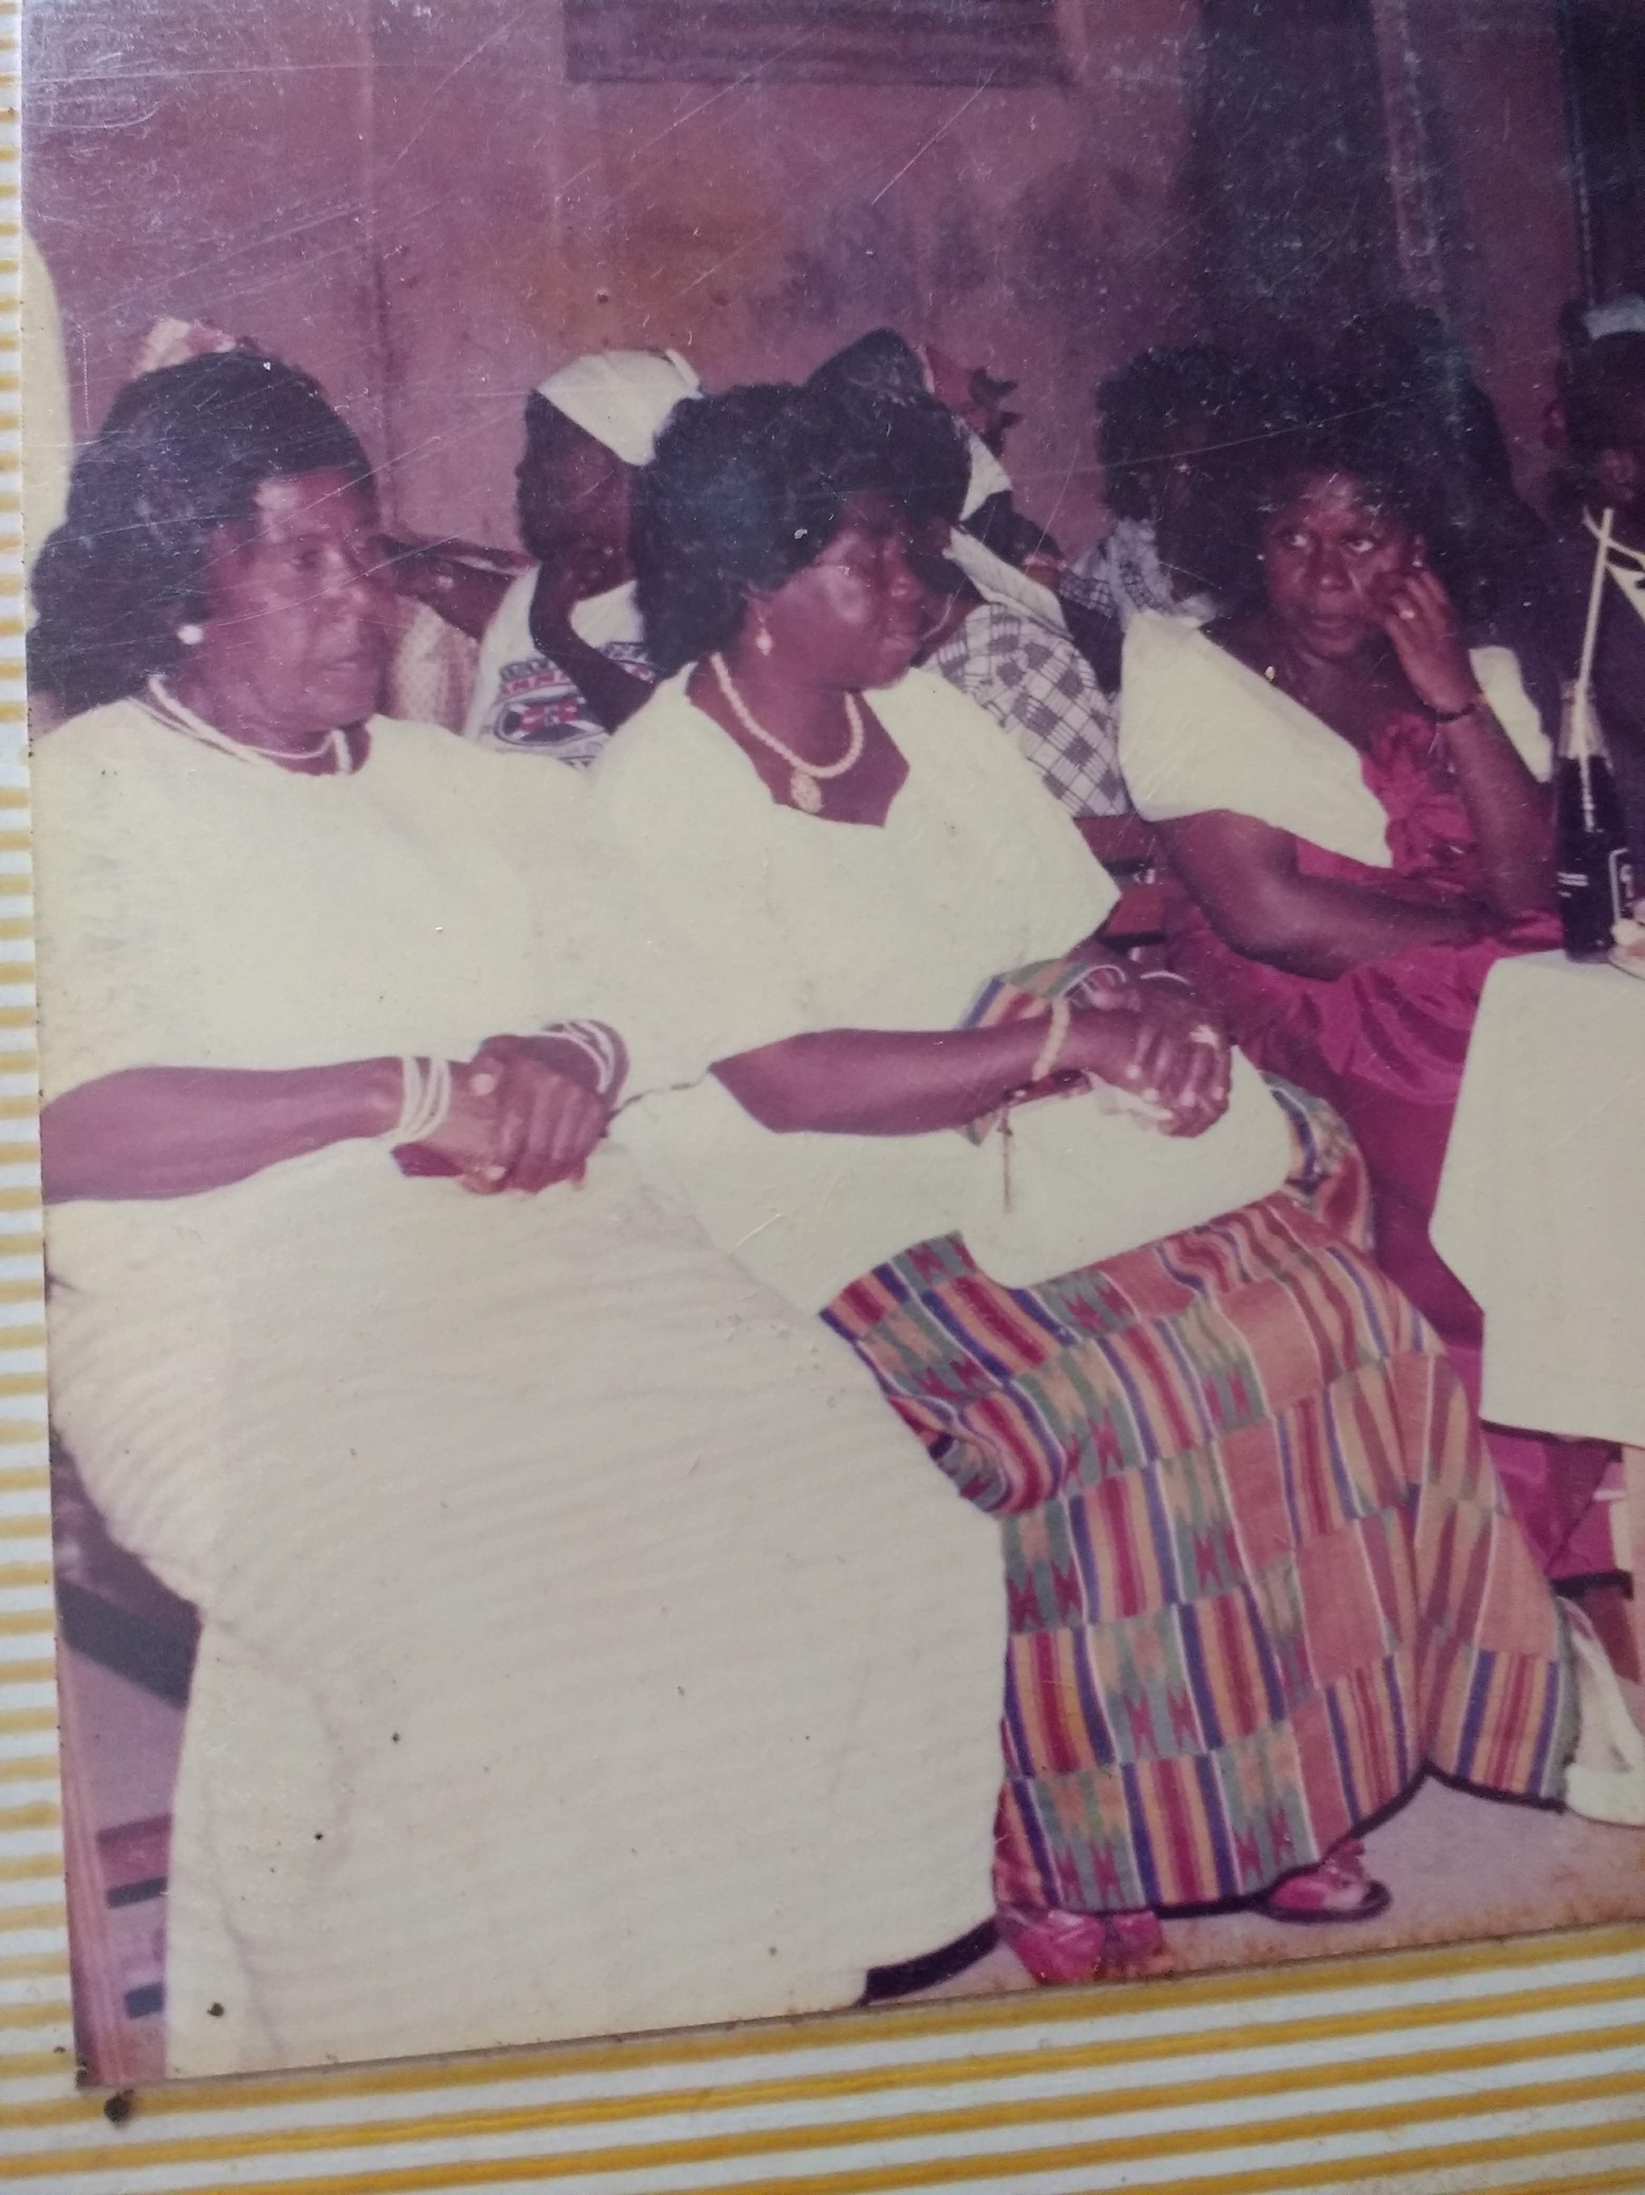
Mahana’s maternal and paternal grandmothers at her parent’s wedding.
Elizabeth Fofo Adjei and Aku Akorli

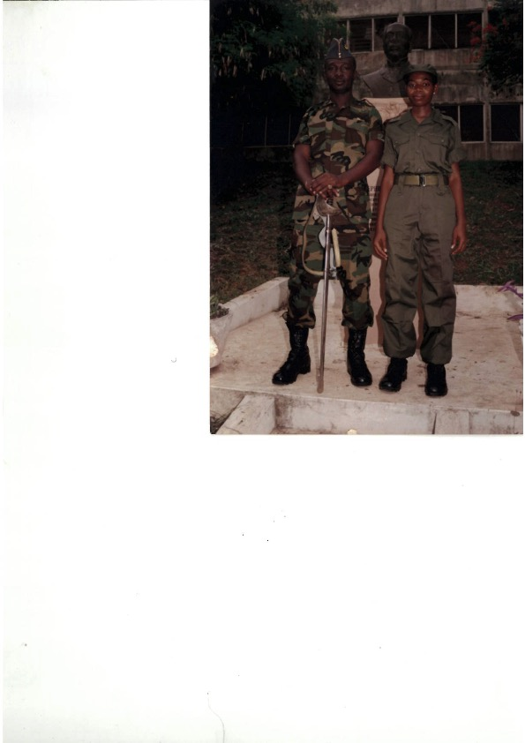
Mahana as a cadet.
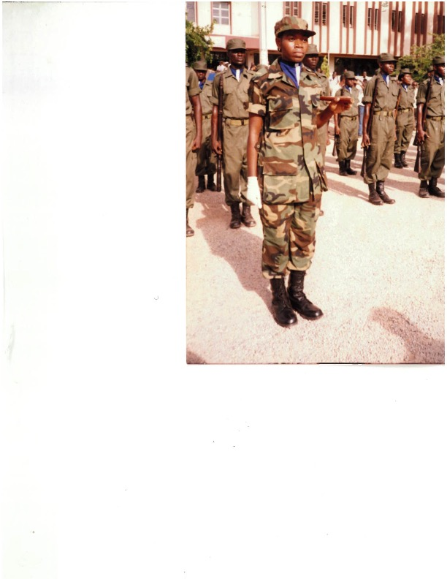
Mahana as a cadet.
Mamobi, Accra, Ghana

Kotobabi, Accra, Ghana
Atendeben flute

Student Cadets

National Theatre
Accra, Ghana

University of Cape Coast
Cape Coast, Ghana

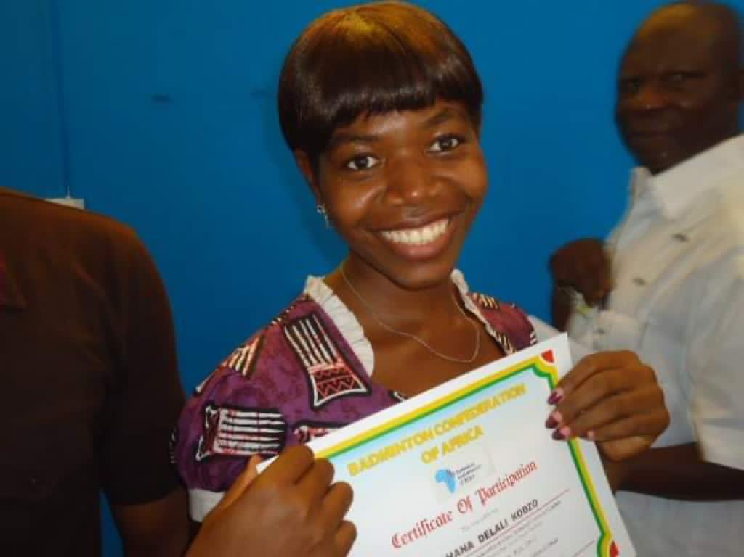
Badminton at the GUSA games.
Mahana took Silver in Badminton for her University!

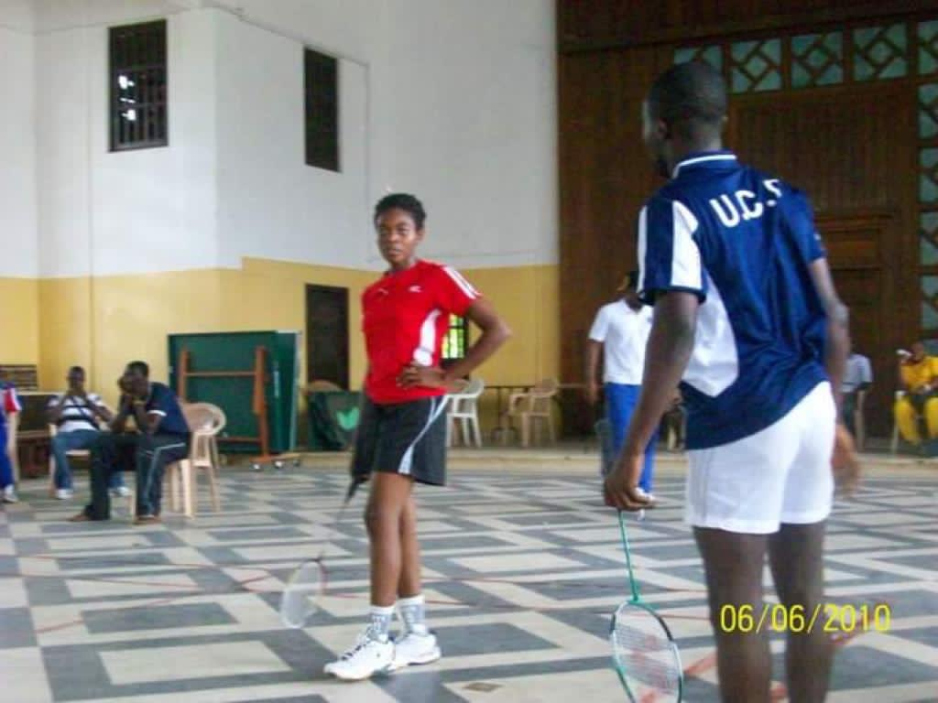
Municipal Assembly Office
Accra, Ghana

Ghana Accra LDS Temple

