Churches support Govt's COVID-19 measures
Tuesday, April 07, 2020 2 Comments
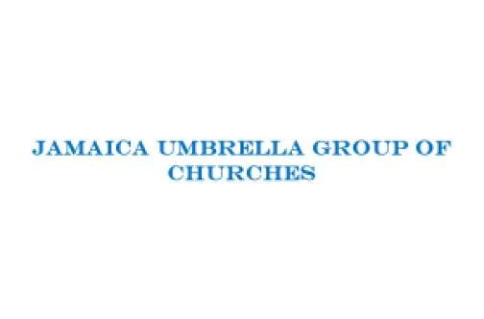

THE Government's management of the novel coronavirus disease (COVID-19) crisis has been commended by the Jamaica Umbrella Groups of Churches (JUGC).
The JUGC, which comprises seven church groups and represents an estimated 99 per cent of the island's Christian community, also expressed support for the night-time curfew imposed by the Government last week Wednesday. The curfew, which runs from 8:00 pm to 6:00 am, is in place for seven days.
Describing the curfew as “a timely and prudent measure to continue the mitigation and suppression of the spread of the COVID-19 virus”, the church group, in a news release, called on “all Jamaicans to fully comply with the requirements of this measure as well as all the other measures announced, such as the washing of hands with soap and water, [and] social (physical) distancing, thus playing their part in keeping Jamaica safe”.
The JUGC said it noted the recognition the Government has received from the World Health Organization for its COVID-19 response and praised the “valiant efforts” of the frontline workers, civil servants, corporate Jamaica, and security officers who have worked tirelessly to secure the safety and security of all Jamaicans.
“Their sacrifices and selfless professionalism are commendable,” the church group said and expressed gratitude to the professionals while offering them support in prayer and solidarity.
“The church will continue to play its part in caring for the most vulnerable in our society and stand ready to partner with Government in its effort to contain the virus and mitigate its effect on our people,” the JUGC said.
Responding to Prime Minister Andrew Holness's warning last week that people who arrived in Jamaica after March 18 and have failed to register with the health ministry, despite repeated requests, are in breach of the law and will be charged when found, the church group said: “We ask all of our members across Jamaica to encourage anyone that they know who came into the island between March 14 and March 28, 2020 to report to the authorities in the common interest of all Jamaicans and themselves.
is shown in the resurrection of Jesus Christ from death, thus demonstrating authority and victory over all of the challenging circumstances which we may face. It is in this reality that we express hope in the midst of the present situation of the COVID-19 pandemic.”
The group also encouraged all Jamaicans to remain calm and peaceful during this period of instability and uncertainty. Additionally. the group invited all pastors to join in a virtual prayer meeting on a national scale on Tuesday, April 14, 2020 in keeping with the recent proclamation by the governor general for the nation to pray.

Pastor arrested
The call from the umbrella church group for members to support Government's measures to contain spread of the novel coronavirus comes hours after the police announced, in a release, that police officers assigned to the Portmore Operational Support Team arrested and charged a pastor on Sunday for breaching the Disaster Risk Management (Enforcement Measures) (No 2) Order 2020.
According to the release, lawmen were summoned to the area about 9:15 am after receiving a report that a church service was in progress at the home of 54-year-old Cynthia Williams in Gregory Park, St Catherine, with more than 50 people in attendance.
Williams is scheduled to appear before the St Catherine Parish Court on Tuesday, July 28.
The police are reminding that no more than 10 people are permitted to gather in a given area. These measures have been put in place for public safety, and breaching the order could result in fines and imprisonment for up to one year.

