The first thing when the Rev. Daniel Greenleaf walks through the door of a nursing home to anoint the sick someone takes his temperature.
Next, he wipes down his vial of holy oil and prayer book with disinfectant before donning a face mask.
He can no longer dab holy oil directly on the forehead and hands of the ill with his thumb the way he always did. Instead, he must use a cotton ball.
After performing his priestly duties, he’ll drop the cotton ball into a Ziploc bag to be burned later.
Parking lot confessionals. Zoom pastoral care.
This is what ministering to the faithful looks like during the COVID-19 pandemic.
ADVERTISING
When the doors closed two months ago to churches, synagogues and mosques in the Twin Cities, congregants lost their houses of worship.
They also were deprived of the ability to sit with their minister, rabbi or imam and confide their troubles and take comfort in their touch.
And clergy in Lewiston and Auburn said they had to adapt quickly to the new restrictions, learning new techniques and technology to tend to the faithful and dole out advice normally dispensed in the confines of their offices or in their congregants’ homes.
These are not normal times.
Even before Maine’s governor directed the state’s residents to stay home, except to perform essential work and tasks, some clergy in the Twin Cities were already gearing up for the challenge.
And while the recent social distancing edicts have limited physical contact, in other ways, they have brought their communities closer together, some clergy members said.
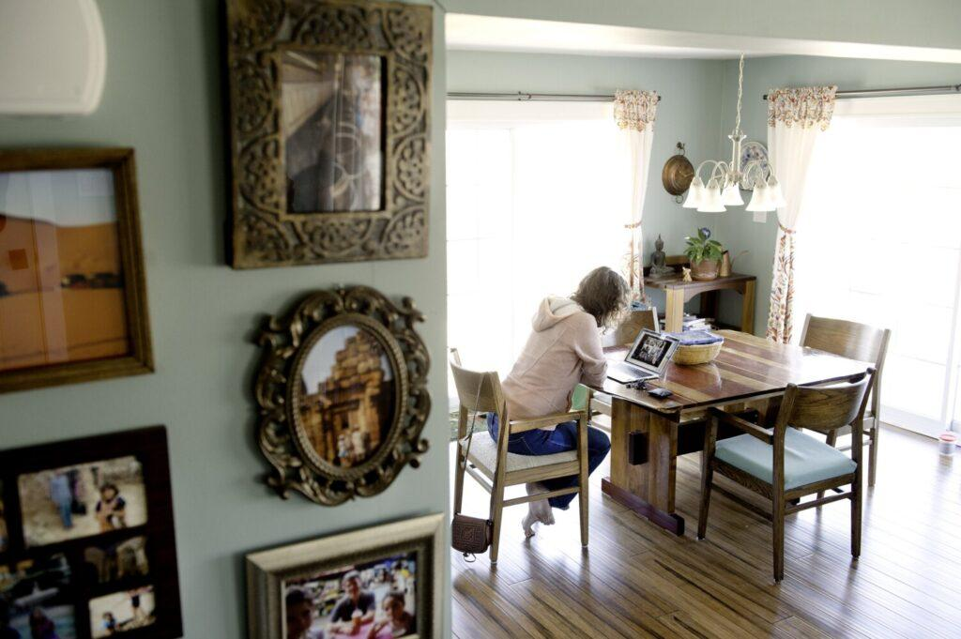
Rev. Jodi Cohen Hayashida chats with her “caring circle” helpers through videoconferencing while sitting at her dining room table in Auburn on Saturday. Hayashida is the pastor of the First Universalist Church in Auburn. Daryn Slover/Sun Journal
The Rev. Jodi Cohen Hayashida, pastor of the First Universalist Church in Auburn, said the first thing she did when her church doors shut was to create “caring circles,” small groups of church members chosen geographically — some in Lewiston and some in Auburn — who would check in with each other weekly for social interaction and any other needs that their fellow congregants might be able to fill.
The groups meet using videoconferencing, a mainstay employed by many clergy in this time of mandated social distancing.
Each circle member filled out a survey, describing any needs they had and any gifts they were able to give, whether it was making masks, or picking up and dropping off groceries or making extra phone calls to people who are feeling really isolated, Hayashida said.
“So that was our first and one of our most important steps, adding on that extra layer of care and contact for folks, since we’re not able to connect in the same way during the week,” she said.
The changes were incremental, but swift and significant, she said.
“Even before Gov. Mills initiated the lockdown we were already beginning to discuss taking precautions,” she said.
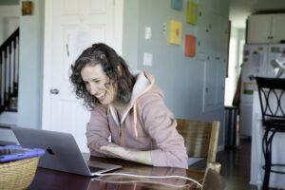
Rev. Jodi Cohen Hayashida chats with her “caring circle” helpers through videoconferencing while sitting at her dining room table in Auburn on Saturday. Hayashida is the pastor of the First Universalist Church in Auburn. Daryn Slover/Sun Journal
“I think we started out one Sunday just saying, ‘Oh, we’re not gonna hold hands during the benediction. We’re just going to, you know, bump elbows.” A week later, “we were even more stringent about it.”
Then they decided to close the church.
“So it was really three weeks of taking massive steps to protect ourselves,” she said.
The Rev. Greenleaf, a priest at Holy Family Church in the Prince of Peace Parish in Lewiston, said his once-frequent visits with parishioners have been curtailed and he now ministers primarily to the sick and dying, and major emergencies because of the new coronavirus, he said.
He hasn’t been called to the bedside of anyone at their home who has been stricken by COVID-19, he said, but he still wears a mask.
Otherwise, most of his days are spent in front of a computer.
Advertisement
“I’m not kidding,” he said.
Rather than meeting with parishioners in his office, Greenleaf said he uses a phone or email to counsel them as he sits in the church rectory.
He and his fellow priests also use social media to connect with their parishioners in April and most of March.
“We have a lot of discussion there as a way to stay connected,” he said. “So we kind of reached out to a lot of our old parishioners who are also on Facebook. We talked about how difficult it’s been, you know, being alone all day and how are you dealing with this?”
They had roughly 180 people signed on to the Facebook group and many more watching, he said.
“It was really a way to kind of talk about some of the things going on in the parish, some ideas about how to deal with what it is we were doing, you know, and how to make the best of it.”
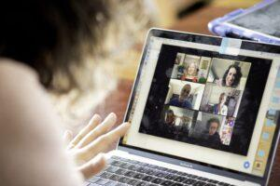
Rev. Jodi Cohen Hayashida and her her “caring circle” helpers discuss what is going well and what could use a little extra work as far as online worship services. Daryn Slover/Sun Journal
Some people reached out directly to Greenleaf, he said, “to say, ‘I’m having a very difficult time with this’ or ‘I’m alone I feel lonely, I miss people’ or that kind of thing.”
The Rev. Annie Baker-Streevey, pastor of Calvary United Methodist Church in Lewiston and Bolsters Mills United Methodist Church in Harrison, said she closed the doors to the Lewiston church after their last service on March 15. “That was the last day congregants could see her face to face, she said.
Certified lay ministers at both churches provide much of the pastoral care, she said, reserving cases of “extreme circumstances” or special requests for her.
Those lay ministers will let her know if she needs to become involved, she said, such as a death or someone being hospitalized.
Since the coronavirus shuttered the church, most of those consultations happened over the phone, she said.
Some younger congregants prefer email or texting, she said.
Advertisement
Baker-Streevey and the lay minsters have been sending greeting cards and contact information to congregants in an effort to stay in touch and reach out in case they have needs that aren’t being met, she said.
She also started a weekly fellowship time using Zoom to visit with each member of the congregation separately.
“Originally it was set up to kind of replace the Sunday morning coffee hour that we don’t have anymore,” she said, “but it’s actually really been a focus of pastoral care because it’s been a good weekly touch point for many of our members to come check in with each other and check in with me, let me know what’s going on and share any prayer concerns, things like that.”
It’s scheduled for an hour every Thursday morning.
“Our congregation is very, very much a family church. For the most part, everyone knows about everyone, they’ve been there long enough,” she said.
“They so care for each other and are such a tight-knit community that they are comfortable sharing those things and relying on each other as a community to take care of one another” Baker-Streevey said. “And of course, I’m happy to be part of that too. But as a United Methodist pastor who gets moved every so many years, it’s wonderful that they’re so tight-knit that they have that grounding relationship with each other.”
Advertisement
Many of the concerns expressed by the church members are the same ones that worried them before the pandemic. But there’s also a lot of discussion around COVID-19, she said.
It’s conveyed as a form of grief, she said.
There’s a collective sense of loss of the way things were before the virus struck Maine.
“They’ve been used to showing up to a physical building every Sunday and now we’re online, which they are grateful for. But there’s a sense of loss there, to not be physically in person with each other. There’s also grief over not being able to see different family members and grief over plans that have changed.”
They try to minimize the importance of it and speak dismissively about it while seeking to remain positive and optimistic, she said, “but I can sense that there is that grief that’s not necessarily being acknowledged by themselves or allowed to feel because I think our whole country has a problem with healthy grief.”
Baker-Streevey said she’s also noticed a strengthening in people’s faith over the past couple of months.
Advertisement
Before the pandemic, she had many conversations with church members who struggled with their faith
“or how to connect with God,” she said.
“But what’s so interesting is that those conversations have not continued even in the midst of a pandemic, of like, ‘Where is God in the midst of a pandemic?'” she said. “No one questions that. In fact, I think, from my experience, people have actually expressed a stronger faith in the midst of this.”
The church made an effort to reach out to older members before the stay-at-home order to ensure they didn’t feel isolated, she said.
“It’s definitely even more of a concern now,” she said.
Rabbi Sruli Desdner at Temple Shalom in Auburn said he’s been counseling members mostly by phone since the synagogue stopped allowing the public inside.
“We just do the best we can,” he said.
Advertisement
Temple members have been accepting of the restrictions and adhering to the social distancing guidelines.
“They want to be safe,” he said.
“I’m very proud of our community,” he said. They’re “well informed and they watch the news and they know what’s going on and they truly want to do what’s right and get through this.”
He’s started using videoconferencing for different purposes, he said, including funerals.
On group videoconferences, members of the synagogue have talked about feelings of anxiety and isolation. But Dresdner said those concerns haven’t reached crisis point.
“Right now it’s just the level of mentioning it, maybe, wanting me and others to know that they’re there, and it’s difficult for them to be socially isolated,” he said.
Advertisement
Most people have put their lives on hold, he said.
“I think people are just waiting. Whatever issues that they’re gonna want to deal with they’re putting on the back burner for now … If you have a toothache, you’re just trying to survive until the dentist office opens up again,” he said. “I think that’s the attitude here. People are really just trying to hunker down, get through this. Be healthy at the other end of it.”
For that reason, he said, there’s actually been less of a need for individual pastoral counseling.
Social media forums aimed at bringing members of the synagogue together have allowed some folks who wouldn’t otherwise have had a chance to connect be part of the conversation, he said, such as those who are summer residents.
“It’s a wonderful blessing that we have these technologies,” he said. “And they are working to keep people safe.”
Dresdner said his mission since the synagogue closed has been to do everything he can “to keep the sense of community, strong, and connection strong.”
“I’m hoping this will be over soon, as everybody else is, and we’ll be able to go back to our building and get together in person,” he said. “I just want to make sure that that feeling of community that we’ve always had remains strong throughout this process.”

