February 28, 2020

A Note from the Bishop on the Coronavirus

Aloha my Siblings in Christ Jesus,

Having just returned from Taiwan, I have witnessed the changes in behavior resulting from the reality of the Coronavirus (COVID-19). The Center for Disease Control and Prevention (CDC) announced: “More cases are likely to be identified in the coming days, including more cases in the United States. It’s also likely that person-to-person spread will continue to occur, including in the United States.”

We must be aware of basic precautions. I commend these CDC webpages on Coronavirus Disease 2019 (COVID-19) and Get Your Community- and Faith-Based Organizations Ready for Pandemic Flu . You can also stay updated through the World Health Organization’s Coronavirus disease (COVID-19) outbreak . I recommend the following from Episcopal Relief and Development: FAITH-BASED RESPONSE TO EPIDEMICS .

What does it mean for the Church? I suggest the following right now:

1. If you’re sick, stay home! Encourage others to stay home if they’re sick. Don’t hesitate to go to the doctor and to urge others to do so.

2. Have alcohol-based liquid hand sanitizer and tissues (to catch coughs and sneezes) readily available.

3. Try to limit meetings. You can also encourage teleconference and Zoom meetings. For the next couple of months, I hope all Diocesan meetings can be done by Zoom.

4. During the exchange of the peace at the Holy Eucharist, limit hugging and offer a simple handshake. It is best to sanitize your hands before and after the peace. One could also just offer a polite bow and smile. Maybe for a time, just greet those immediately around you without passing throughout the congregation. Most importantly, recognize and respect it when a person doesn’t want to exchange the peace with physical contact or at all.

5. When taking Holy Communion, reconsider intinction. As I have written in the Diocesan Customary :
- If a communicant wishes the wine, then take a small sip from the common cup. In the Episcopal Church, this is the most typical and generally preferred means of taking the Sacrament of Holy Communion.

- I am increasingly concerned that receiving the Sacrament by intinction when the communicant dips the bread themselves into the cup of wine is the least sanitary means of receiving Holy Communion. It is therefore recommended that congregations stop practicing self-intinction for sanitary reasons. Our hands are often very unclean and many hands dipping into a common cup is less sanitary than a simple sip from a common cup. Let’s keep many fingers out of the common cup.

- If intinction is maintained, then please consider moving to having the Eucharistic Minister administering the Sacrament: “It should be noted that some congregations practice a form of intinction in which the communicant holds the host in the palm of the hand and the Eucharistic Minister takes the host, dips it slightly in the wine and then places it on the person's tongue.” In this case the Eucharistic Ministers should sanitize their hands before and after administering the Sacrament to God’s people.
﻿
- If concerned, it is recommended that the communicant just receive the bread when taking the Sacrament and forego the cup altogether. The Sacrament’s validity and efficacy is total. While the normative practice in the Episcopal Church is to consume the bread and then to share the wine from a common cup, a person may receive the Sacrament in one kind (just the bread) when necessary for reasons of personal health or well-being, or because of personal piety and practice. Typically, this is practiced by taking the bread into the hand alone and then crossing one's arms over the chest when the wine is offered.

I encourage you to read the following from the Diocese of Toronto: A SUMMARY REPORT CONCERNING THE RISK OF TRANSMISSION OF CONTAGION VIA THE USE OF THE COMMON CUP AND OTHER LITURGICAL ACTS and from the Church of England: Coronavirus (COVID-19) guidance for parishes.

Should events cause additional measures to be needed, I will be in touch as soon as possible. Most importantly, we all need to use common sense, don’t be anxious, stay informed, get plenty of rest, take care of ourselves, and say our prayers.

Please read the material in the links that I have shared to help prepare for the weeks and, perhaps, months ahead of us.

Assist us mercifully, O Lord, in these our supplications and prayers, and dispose the way of your servants towards the attainment of everlasting salvation; that, among all the changes and chances of this mortal life, they may ever be defended by your gracious and ready help; through Jesus Christ our Lord. Amen.
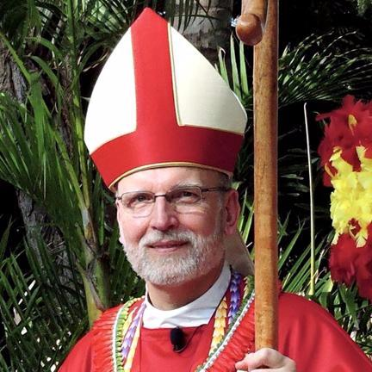
Aloha ma o Iesu Kristo, ko mākou Haku,

+Bob

The Right Reverend Robert L. Fitzpatrick

Bishop Diocesan
The Episcopal Diocese of Hawai'i

Bishop-in-Charge
The Episcopal Church in Micronesia

