How to Protect Your Zoom Meetings/Classrooms (updated 4-13-20)

NEW!! Zoom has released an important security and toolbar update. Please review it carefully and make sure you update your Zoom desktop client (and any other devices you have - instructions are in the blog post). We will be updating this document to reflect these new changes but still suggest you review our recommendations and explanations.

There are many articles, posts, and advice on how to protect and, in some cases, lock down your Zoom meetings. Some refer to these intrusions as Zoombomings. This guide is designed for educators who may not be experts in Zoom (yet) and to help you find the right balance between features you want and visitors or actions you do not. Our approach is that there is NO one right way to do this and there will be some choices and trade-offs that may change over time. You will find some “Rashi”/explanation throughout for those who want to understand why. And you’ll find links to the articles and references at the end (mostly from Zoom) that we find the most helpful.

PART A: What EVERYONE should do NOW/BEFORE you run any more meetings:
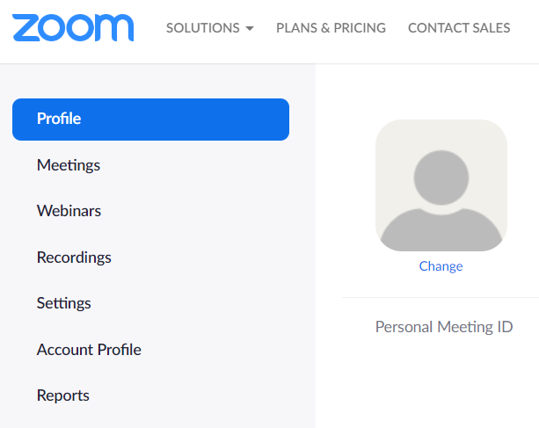
Zoom account settings (what we call the backend)
Every zoom account (even the basic/free) has a “Settings” panel that will set how every one of your Zoom meetings will look and feel. Some of the settings can be overridden when you schedule your meeting and some during the meeting. These instructions are based on logging into your Zoom account on the web (which we recommend).
- Go to https://zoom.us
and “Sign In” near the
top right corner. You
will end up on your
Profile page that should
look like this (if it doesn’t
make sure you are viewing the page fullscreen).
Click on “Settings” on the
Left-hand menu.
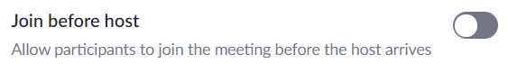
These are our global recommendations - most of them will be to TURN OFF or not enabled (in Zoom that means “grayed out” - example below): There are some exceptions so please use this as a checklist. We’ve listed them in the order they appear.
(**indicates you can OVERRIDE this when scheduling or while in a meeting).
- **Join before host (OFF)
- **Use Personal Meeting ID (PMI) when scheduling a meeting (OFF)
- Embed password in meeting link for one-click join (OFF)
Because this adds the password into the zoom link which you want to keep separate.
- **Chat (oy)! There are three different settings for “Chat” (and
we will offer a brief explanation about each for clarity).
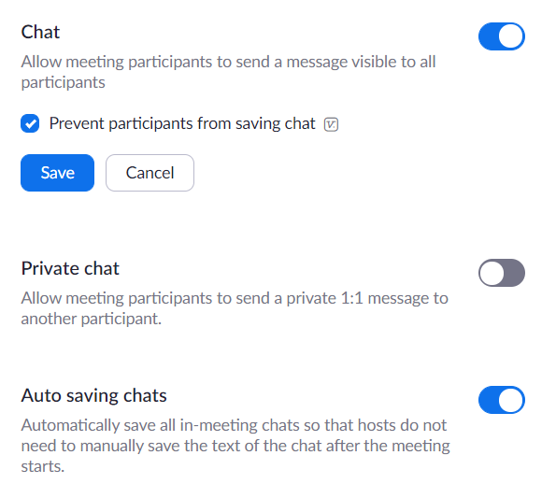
  - Chat can be very useful pedagogically and can be adjusted once in the meeting, so we recommend enabling “Chat” globally (ON) and disabling when called for.
  - However, we recommend disabling “Private-chat” (OFF) as a child protection and anti-bullying measure.
  - Saving chat files has two settings.
    - The top one “prevent participants” (not the host or co-host) from saving the chat,
has a special checkbox that
you must “Save” (most other changes are automatically saved).
    - “Auto saving chats” (ON) means you don’t need to remember to save the chat before you end the meeting.
- Play sound when participants join or leave
Although this can be a little annoying at times, we recommend turning this on (ON) AND, IN ADDITION, choose the option for “Heard by host only.”
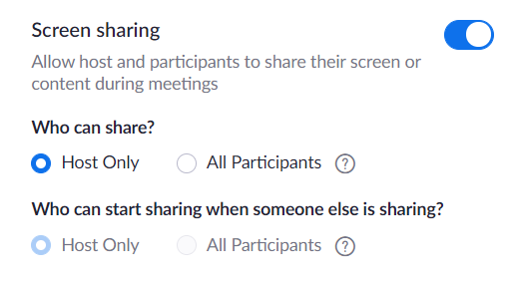
- File transfer (OFF)
- **Screen sharing also has two settings:
  - You want the ability to share screens so you SHOULD
turn this on (ON)
  - BUT you want to make sure ONLY the host has the default option to share so choose HOST ONLY.
Remember the first rule of Zoom: Don’t give up control of your screen!
- Annotation - which refers to writing on ANY shared screen, not just a whiteboard.
This is a little tough. If you don’t think you will want it at all, then it is best to turn off. But if you might want it, then you will need to enable it in the settings and then you override it in the meeting BUT NEED TO REMEMBER TO DO SO!
  - Afraid of Zoomboming? Recommend not enabling it (OFF)
  - Think you can handle controlling whether participants can use or not during a meeting/class? Enable it now (but learn how to manage it in practice sessions).
- Whiteboard (side note that some of us are not big fans of the Zoom whiteboard and we think there are better tools that you can employ instead).
  - That being said, you might as well enable it (ON) since you have already set the default that ONLY the host can share (unless you override that in a meeting).
  - Be sure to also check “auto-save” so if you do use a whiteboard, it will automatically be saved like your chat.
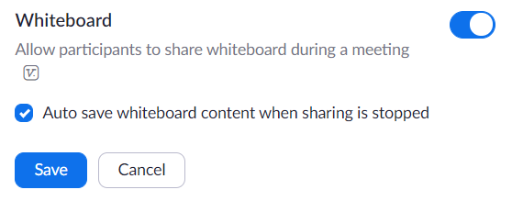
- Remote control (OFF)
- Allow removed participants to rejoin - not so clear so we have two recommendations:
  - Afraid of Zoomboming? Recommend not enabling it (OFF)
  - Worried about a student or parents accidentally being kicked out? Enable it (ON) and be prepared to lock the meeting should you need to stop someone from re-entering.
- Far end camera control - should already be (OFF)
- **Waiting Room (people say YES, but…)
The plus is that you will have to admit anyone who wants to enter. Yes, you can admit all that are waiting at once but you will need to continue to do so one at a time or in small groups if folks arrive late. You cannot turn off the waiting room once a meeting starts (but you can lock the meeting). If you know everyone who will be coming and you have the time or someone helping to let them in, great. But if not, this really won’t help and will give you a lot more work to do. Special note: If you enable it in the settings, you can turn it off when scheduling (and vice versa). Also, Zoom just announced that starting March 31, the Waiting Room feature will be automatically turned on by default.

PART B: What to control/adjust when you START or During a meeting:
- Click to open “Manage Participants” and if your screen is big enough, place the window where you can easily see it (might be difficult on a laptop).
  - Click on the “More” button in the bottom right corner just to be aware/remind yourself what options you have.
  - Most important at the end of the list is Lock Meeting which you can do once everyone you want is in your Zoom meeting.
- Check your Share Screen options by clicking on the small up arrow on the right of Share Screen and make sure that Only Host is selected under Who can share?

PART C: What to do IF YOU HAVE AN INTRUDER:
Since you will likely be stressed by this, the order suggested is ideal but not required.
- If a screen is being shared with inappropriate material, takeover the Share as host and share anything else (this can be avoided with the proper safeguards in Section A.
- Go to/open “Manage Participants”
  - Remove the intruder by clicking or rolling over their name,
  - choose More and then
  - Remove (the last option on the list).
- If you have not already done so, Lock Meeting on the same Manage Participants list/window in the bottom right corner where it says “More” (near the end of the list).

What we are reading and where we are getting our information:
If you have questions or other suggestions, please contact our Director Online Educational Content at onlineresources@jewishedproject.org.

- From Zoom
  - NEW! Zoom Product Updates: New Security Toolbar Icon for Hosts, Meeting ID No Longer Displayed (4.8.20)
  - NEW! Support during the COVID-19 Pandemic
Includes a special section (#2) for Educating Over Zoom: Here’s how teachers, administrators, and students can successfully spin up virtual classrooms, participate in online classes, and use Zoom for distance education:
  - A Message to Our Users (4.1.20) by Eric S. Yuan, Founder and CEO
  - Best Practices for Securing Your Virtual Classroom (3.27.20)
  - How to Keep Uninvited Guests Out of Your Zoom Event (3.20.20)
  - School Administrator’s Guide to Rolling Out Zoom (3.20.20)
- From others
  - From SAR Academy/HS in Riverdale, ZOOM Meetings - Intrusion Prevention

