COVID-19 Rewrites Ramadan Rituals - Jamaica-Based Muslims Adapt As Mosques Remain Empty
Published:Thursday | April 30, 2020 | 12:19 AMJudana Murphy/Gleaner Writer
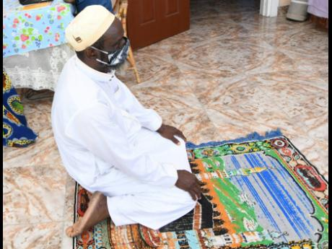
Rudolph Brown/Photographer
Sheikh Musa Tijani, head of Islamic Education at the Islamic Council of Jamaica, kneels on a prayer mat at home in Vineyard Town, Kingston, on Tuesday.
COVID-19 has unravelled the thread of worship and social cohesion that bind Jamaica’s 6,000 Muslims, but adherents have, like other people of faith, adapted rituals to cope with the new norm of distancing.
This reality has become more apparent in the holy month of Ramadan – marked by introspection, communal prayer, and fasting – which started last Thursday.
Ramadan will not be the same this year.
The coronavirus pandemic floored Michael and Sharon Gillett-Chambers’ plans to visit the holy city of Mecca in Saudi Arabia this year.
Michael, a Jamaican, and Sharon, a Trinidadian, operate the popular baby supplies retail store Simply Halal and mostly worship at the Central Masjid on South Camp Road in Kingston. But the government statute bans gatherings exceeding 10 people.
“It’s the first time ever I’m experiencing a Ramadan like this. Ramadan is our beloved month. It is an exciting month for us ... ,” Mrs Gillett-Chambers said.
“As Muslims, we pray together, we touch shoulder to shoulder, so with the social distancing in effect, we can’t do that.”

MISSING THE FELLOWSHIP
The couple have two children – a nine-year-old and a 12-year-old – who also partake in the fasting, prayer, and last-day festivities of the month.
But the family misses fellowshipping with believers at the Masjid, especially for Iftar, the dinner that ends the daily fast in a country that has become a melting pot of Muslims from Guyana, Nigeria, Pakistan, India, Jordan, and Palestine.
“Different families put on the Iftar dinner, and so you may go to the Masjid today and it’s a Pakistani cuisine, you may go tomorrow and it is an African cuisine. Muslims look forward to the month of fasting, and I have spoken to so many Muslims that I have seen since Ramadan, and everybody is, like, almost in mourning. They miss it so much!” Mr Gillett-Chambers said.
Like the Gillett-Chamberses, Sheikh Tijani, head of Islamic education at the Islamic Council of Jamaica (ICOJ), has also repurposed a room for prayer to Allah.
COVID-19 does not exempt worshippers from fasting, said Tijani, unless they have tested positive for the virus or have received medical advice.
“We believe that the coronavirus is a test from God, so everyone of us needs to pass the test,” he said.
There are 14 Islamic places of worship in Jamaica, with the largest congregation being at the Central Masjid.

ENGAGING DIGITALLY
Though they are not able to gather for the various prayer sessions, Tijani has found means to engage members digitally. Tijani shared that there are a number of new Muslims, mainly in the downtown area, who will be observing Ramadan for the first time.
“When it’s time for prayer, we get all the community in Kingston on WhatsApp, and we had the Zoom discussion three days before the fasting, and there will be another one, maybe on Wednesday, so they can ask questions,” he said.
Muslims often consume three dates to break their fast, but securing the commodity was a challenge.
“We usually get it from California, UK, or Saudi Arabia, but this year, we only had one source. The one that we got, we tried to stretch it and package it to make every Muslim in Jamaica get,” Tijani said.
Thirty dates were placed in each bag to allow for worshippers to break their fast with one each day.
He said that the most frequently asked question by Muslims regarding Ramadan is how the last day, known as Eid-al-Fitr, the festival of breaking the fast, will be celebrated.
“If the coronavirus continues, we will ask every family to cook, get the best of their clothes, and sit down in your house. We will announce the time of the prayer so that you will be able to do the same prayer in your house,” Tijani explained.
Mr Gillett-Chambers is of the view that COVID-19 would not have the chance to spread if Islamic practices were followed by all.
“We are required to wash our hands five times a day at least, and every time we use the bathroom, we have to purify ourselves,” he said, adding that handshaking, hugging, kissing, and other forms of contact are limited.

