#JamaicaTogether | We Must Stand Together, Muslim Leader Urges J’cans - Unity Key To Surviving COVID-19 Pandemic, Says Tariq Azeem
Published:Sunday | May 3, 2020 | 12:14 AMCorey Robinson - Senior Staff Reporter
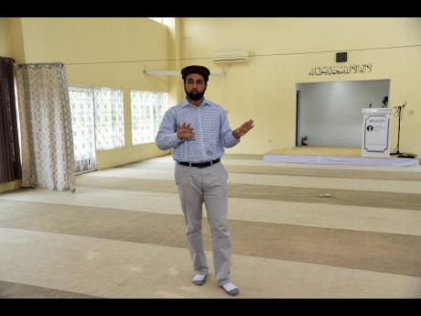
Ian Allen/Photographer
Tariq Azeem, head of the Ahmadiyya Muslim Jama’at community in St Catherine, is urging Jamaicans to look out for their less-fortunate neighbours who might need a helping hand to survive the COVID-19 pandemic.
The coronavirus pandemic has claimed nearly 250,000 lives around the world and has heaped great suffering upon humanity, but if Jamaicans focus on becoming more charitable towards each other, the resilient island will stand strong in the face of the disease.
The only other missing ingredient needed to survive the virus and the dreaded COVID-19 respiratory disease would be unfaltering faith, which Tariq Azeem, head of the Ahmadiyya Muslim Jama’at community in St Catherine, says abounds in Jamaica, with all its varying religious groups.
“It (faith) is absolutely relevant in this time because around the globe, not just in Jamaica, we are seeing the best of people during COVID-19 and the worst of people,” Azeem told The Sunday Gleaner last Tuesday.
“There are people who are hoarding food items and snatching things from stores and making the less fortunate suffer more, and then there are also good people who are trying to help, knowing that some people are suffering,” he said.
“We should realise that we are a global family and instead of just feeling sorry for your own kind, we should feel sympathy for mankind. That is important. We have to be worried about everyone,” continued Azeem, who is a citizen of Canada, which has recorded more than 55,000 cases of the coronavirus. His father and other relatives are still in the North American country.
“We are talking about small things,” said Azeem, citing regular checks on the elderly as one example of how Jamaicans could help their fellowmen cope. “This is how we have to look out and care for one and another. This is how we will fight COVID-19.”

START WITH THE NEEDIEST
He said that while most people are unable to assist large groups of individuals, Jamaicans should start with the neediest closest to them.
“It is hard to know who is in need across the country, but each of us knows who is in need or suffering in our own neighbourhood. We just have to take responsibility in our own spaces,” Azeem charged.
Almost two billion Muslims across the globe and some 6,000 Muslims locally are currently acknowledging the month-long Ramadan festivities marked by introspection, communal prayer, and fasting each year.
However, the coronavirus pandemic and the Government’s social-distance orders have rewritten the script for those activities, causing most worshippers to carry out their five daily prayers at home.
At the same time, the Ahmadiyya community in Old Harbour said it has been purchasing items in bulk and has been distributing care packages to less-fortunate residents in St Catherine, where a 17-day lockdown, imposed to curtail the spread of COVID-19 in the parish, expired on Friday.
Some religious groups have come under criticism for observing the Government’s stay-at-home orders and not meeting for worship. Azeem, however, said that disobeying the protocols would be irresponsible of religious leaders.
“They should be following first what the Government is saying. If you don’t do that, then what you are doing is saying that your religion and the Government cannot [coexist]. As Muslims, we believe that you practise religion, but you must not disobey the local laws,” he said, emphasising the importance of unity in the face of the deadly pandemic caused by the highly contagious virus.
“In this time, it becomes even a greater necessity to stand together as one community and one family. The religious and faith communities, this is our most important time … . Whatever religion you belong to, we must stand together as Jamaicans and as a global community. We are humans and we must fight COVID-19 together. Share with one another, share love, and be ready at the forefront,” he urged.

